SWITCH
The switch generator for BVE

© 2002 Rüdiger Hülsmann

1. Introduction

Here it is, the switch generator for BVE! Now, the dream has come true to create realistic switches for BVE. This has always been a hard work so far, but now it is done automatically: Just enter the data of the switch and that’s it!
But that is not everything yet: Optionally, you can add overhead lines, for each track! Furthermore, the B3D-File of the switch contains useful information to make installation and modification as easy as possible.
A curve generator is also included in order to create smooth curves.

2. Technical

The generator allows to create nearly every type of switch. Whether it is a normal, a curve or a Y-shaped switch, anything goes.
But it should be mentioned that the generator operates on trigonometric base, i.e. it does not actually calculate the curve but the offset on the x-axis. If the turnout radius is very steep, this results in a narrowing of the track width because the rails are diagonal, but they always have the same x-distance from each other.
The following picture illustrates the issue:

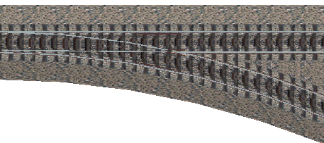

You can clearly see how the generator works: The right track has not been turned but shifted. This causes a narrowing of the track width, of couse. However, this effect can only be seen with extremely steep branch radii, in the picture, it is 63m. If the turnout radius is greater than 150m, this effect can hardly be seen anymore. Less that 150m turnout radius are not recommended anyway, as the switch would be too angular in this case. The switch is separated in 5m sections, so the graph is very smooth with radii greater than 150m.

3. Functions of the program

After starting the program, you will be asked to select your language. You may choose between German and English.

Now comes the selection menu. Here you select the object you would like to create. You may choose between switches, curves and three types of crossings.

3.1 Creating a switch

The following parameters are queried successively:

- Length of the switch (a)
- X-offset of the right branch (b)
- X-offset of the left branch
- Direction of travel (c)
- Guard rails (d)
- Compensating pieces to reach the next 25m (if needed)
- Overhead line right
- Overhead line left
- Height of the contact wire
- Height of the carrying rope

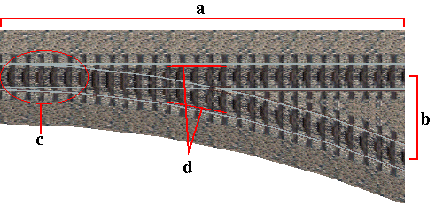

The picture illustrates the different options. The functions are now explained seperately:

Lenght of the switch:
The lenght of the switch from the beginning up to the end. It refers to the z-axis, which represents a straight branch, even if the two branches are curved.

X-offset of the right/left branch:
The distance between a branch at the end of the switch and the zero-position. Enter negative values to create a branch to the left, a zero must be entered for a straight track.

Concerning „right“ and „left“: These terms are meant in a relative way. That means, if both tracks branch to the left, the one which goes more to the left is the “left” one, so it has a smaller (in mathematical sense) x-offset than the other one which would be the “right” branch.

Because of the frog calculation, the x-distance between both branches has to be at least 1.75m, else the rails might not cross each other. When using switch connections, this results in a smallest track distance of 3.5 meters.

Direction of travel:
Indicates the direction of the switch. As far as “right” and “left” are concerned, the definition mentioned before applies here as well.
The direction of the switch is independent from its function, of course you have to add a curve in the track file according to the switch direction, if you want to drive on a curved branch.

Guard rails:
Guidances at the outer rails in the frog area. They exist on every normal switch, but nevertheless, you can turn them off because they result in graphical problems when creating double track connections.

Compensating pieces:
If you create a switch of which the length is no multiple of 25m (length of rasters), you may add the missing meters up to the next 25m section here. If one of the branches is straight, you may add the compensating pieces at the beginning and the end of the switch, otherwise only at the beginning.

Overhead line:
Overhead lines can be created seperately for the left and the right branch. The height of the contact wire and the carrying rope is adjustable.

Finally, you enter a file name to save the object. The name must not exceed 8 characters. Please enter the name without the extension which will be added automatically.

3.2 Creating a crossing

To create a crossing, you have to enter the same parameters as if you would create a switch. The only difference is the way you enter the direction of travel:
There are three possibilities:
- normal track, straight
- normal track, branch
- crossing track

If you want to create a simple crossing, you don’t need to enter the direction, of course.

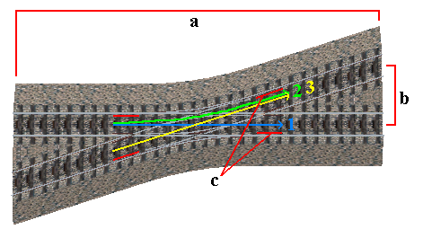

3.3 Creating a curve

Of couse, it is much easier to create a curve than a switch. There are two possibilities to do this:

Entering the radius:
Here you can enter the radius of the curve. This function is especially suitable for creating curves with a given radius. The radius should be at least 150m, otherwise the graph would be inaccurate. More than 1500m are not necessary, as the standard curves would be completely sufficient.

Entering the x-offset:
This function is actually very similar to the creation of the switch branches.
So it is suitable to create counter-curves for existing switches.

Turning to the outside:
To create a curve in BVE, the track piece has to be turned its own angle to the outside. This can be done automatically if you want, so you can use the curve as a rail(x) object.

4. Rework and installation

As mentioned at the beginning, the switch generator writes all the necessary information into the B3D-file. The specification of the angle and the radius of the switch are of the greatest importance for the installation, as these values have to be entered in the track file.
Furthermore, the head of the file includes a list of all the switch data and the existing and non-existing parameters.

In the source code you can find comments to the individual parts of the switch like rails, guard rails, etc. So you can find and modify the corresponding parts very easily and quickly.
For example, it is no problem to remove the overhead line of the switch later.

A common case of modification is also the creation of rusty rails. For this, set the color of the concerned rail to 85,50,50 and change the y-value to –0.010, so that the rusty rails are below the used ones and overlaid by them.

Of couse, the textures of the ballast and the sleepers may also be modified by changing the file name. This program already contains adapted switch textures of my two track types.

5. Problems and prospects

The main problem of the program is its linear structure. That means that you always have to enter all the parameters to create the switch. It is not possible to load a switch and to add or remove parts. Maybe this will be improved when new functions become available.
Furthermore, the program is not “fool save”. It will crash mercilessly if you enter a character instead of an integer. But in most cases, a message will appear and you may try again.

6. Copyright

As usual, this is my program and it will stay mine, alright?
Decompiling and modifying the program is not allowed.
The created switches are not concerned by the copyright, you may modify and publish them as you like.
I am not responsible for any damages this program may cause.

Alright then, happy track-building!

Rüdiger Hülsmann, 01.02.2002

http://home.t-online.de/home/r.hulsmann

E-Mail always appreciated at r.hulsmann@gmx.de

